MACHINE LEARNING
LAB - 1

Question 1:
Create a NumPy array containing the integers from 1 to 20.
Perform the following operations:
1. Display the array.
2. Find the shape of the array.
3. Find the maximum and minimum values.
4. Calculate the mean and standard deviation.
5. Reshape the array into a 4 × 5 matrix.
6. Display the second row of the matrix.
7. Display the third column of the matrix.

Code:
#Question 1

#1 Displaying the array
import numpy as np

arr = np.array([1,2,3,4,5,6,7,8,9,10,11,12,13,14,15,16,17,18,19,20])

print(arr)

#2 Find the shape of the array

print(arr.shape)

#3 Find the maximum and minimum values

#Alternative method
print(arr.max())
print(arr.min())

# 4 Calculate the mean and the standard deviation

mean_val = np.mean(arr)

std_val = np.std(arr)

print(f" The mean is : {mean_val} ")
print(f" The standard deviation is : {std_val} ")

# 5 Reshape the array into a 4*5 matrix

new_arr = arr.reshape(4,5)

print(new_arr)

# 6 Display the second row of the matrix

second_row = new_arr[1]

print(second_row)

# 7 Display the third column of the matrix

third_col = new_arr[:, 2]

print(third_col)

Output:
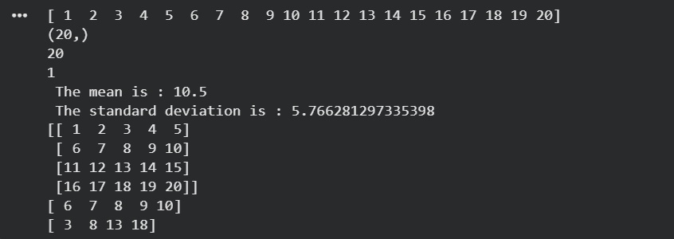

Question 2:
Create two NumPy arrays:
A = [10, 20, 30, 40, 50]
B = [5, 10, 15, 20, 25]
Perform:
1. Addition of A and B.
2. Subtraction of B from A.
3. Element-wise multiplication.
4. Element-wise division.
5. Find the sum of all elements in A

Code:
#Question 2

import numpy as np

A = np.array([10,20,30,40,50])
B = np.array([5,10,15,20,25])

print(A)
print(B)

# 1.Addition of A and B

add = A + B
print(add)

# 2.Subtraction of A and B

sub = A - B
print(sub)

# 3.Element-wise multiplication

mul = A * B
print(mul)

# 4.Element-wise division

div = A/B

print(div)

# 5.Find the sum of all elements in A

total_sum = np.sum(A)
print(total_sum)

Output:

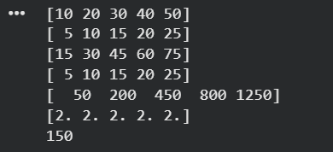

Question 3:
Create a DataFrame using the following student data:
Roll No Name Marks
101 Ravi 85
102 Priya 92
103 Kiran 78
104 Anu 88
105 Sita 95
Perform the following operations:
1. Display the DataFrame.
2. Display the first three records.
3. Find the average marks.
4. Find the student with the highest marks.
5. Find the student with the lowest marks.
6. Add a new column called "Grade" using:
A for Marks ≥ 90
B for Marks between 80 and 89
C for Marks < 80

Code:

#Question 3

import pandas as pd

dataframe = pd.DataFrame({
"Roll No" : [101,102,103,104,105],
"Name" : ["Ravi" , "Priya" , "Kiran" , "Anu" , "Sita"] ,
"Marks" : [85 , 92 , 78 , 88 , 95]

})

# 1.Display the dataframe
print(dataframe)

# 2.Display the first three records

print(dataframe.head(3))

# 3.Find the average Marks

avg_marks = dataframe["Marks"].mean()
print(avg_marks)

# 4.Find the student with the highest marks

highest_mark = dataframe["Marks"].max()
print(highest_mark)

# 5.Find the student qith the lowest marks

lowest_mark = dataframe["Marks"].min()
print(lowest_mark)

# 6.Add a new column "Grade"

dataframe["Grade"] = ["B" , "A" , "C" , "B" , "A"]

print(dataframe)

Output:

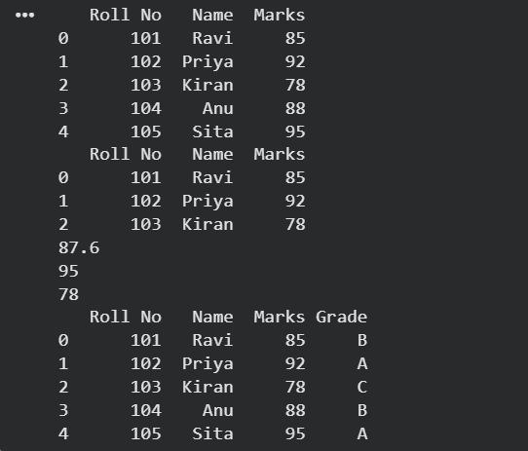

Question 4:
Create a DataFrame containing the following information:
Product Price Quantity
Laptop 50000 10
Mouse 500 50
Keyboard 1200 30
Monitor 10000 15
Perform:
1. Calculate the total value of each product using:
Total Value = Price × Quantity
2. Add the Total Value column.
3. Find the product with the highest total value.
4. Calculate the overall inventory value.

Code:
import pandas as pd

df = pd.DataFrame({

"Product" : ["Laptop", "Mouse", "Keyboard", "Monitor"],
"Price" : [50000, 500, 1200, 10000],
"Quantity" : [10, 50, 30, 15]
})

# 1. Total Value = Price * Quantity

df["total_val"] = df["Price"] * df["Quantity"]

print(df["total_val"])

# 2. Add the Total Value column
print(df["total_val"].sum())

# 3. Find the product with highest total value

print(df[df["total_val"] == df["total_val"].max()])

# 4. Calculate overall inventory value

print(df["total_val"].sum())

Output:

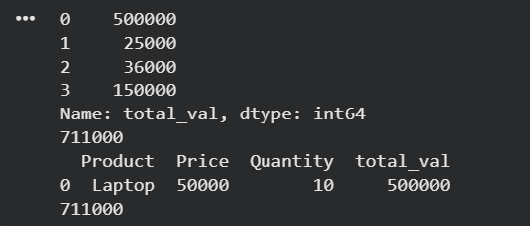

Question 5:
Download the Iris dataset from Scikit-learn and perform the following:
1. Load the dataset into a Pandas DataFrame.
2. Display the first five records.
3. Find the number of rows and columns.
4. Display column names.
5. Check for missing values.
6. Generate summary statistics using describe().
7. Find the number of samples belonging to each class.

Code:
from sklearn.datasets import load_iris
import pandas as pd
iris = load_iris()
df = pd.DataFrame(iris.data, columns=iris.feature_names)
df["Target"] = iris.target
print("First Five Records:")
print(df.head())
print("\nNumber of Rows and Columns:")
print(df.shape)
print("\nColumn Names:")
print(df.columns)
print("\nMissing Values:")
print(df.isnull().sum())
print("\nSummary Statistics:")
print(df.describe())
print("\nNumber of Samples in Each Class:")
print(df["Target"].value_counts())

Output:

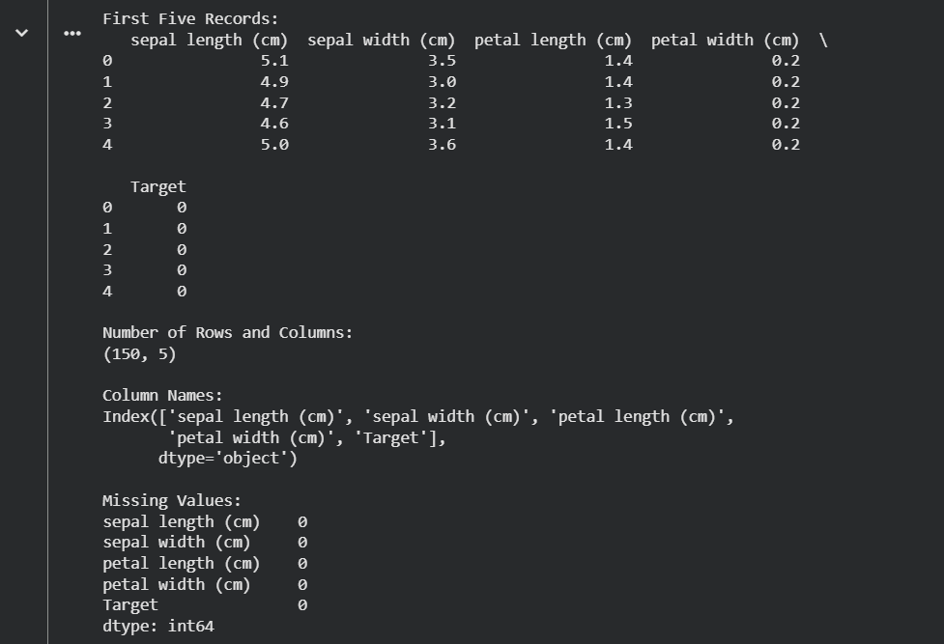
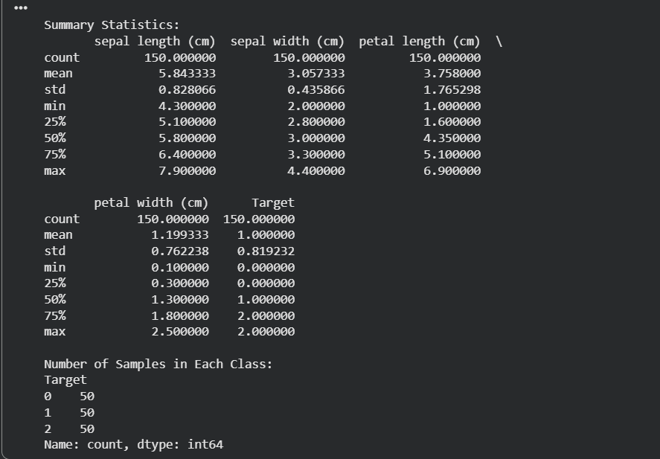

LAB – 2

Aim : To perform exploratory data analysis (EDA) on a student performance dataset using Pandas and Matplotlib.

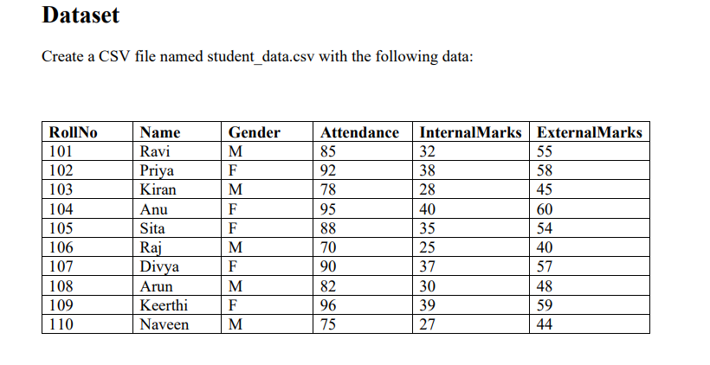

Tasks

Task A: Dataset Loading and Inspection

• Import the necessary Python libraries.
• Load the dataset into a Pandas DataFrame.
• Display the first five records.
• Display the last five records.
• Find the total number of rows and columns.
• Display the names of all columns.
• Display the data type of each column.
• Generate dataset information using info().

Code:

#Task A
import pandas as pd

from google.colab import files

uploaded = files.upload()

df = pd.read_csv("student_data.csv")

print(df)

# Display the first five records
print(df.head(5))

#Display the last five records
print(df.tail(5))

# Find the total number of rows and columns

print(df.shape[0])
print(df.shape[1])

#Display the names of all columns.
print(df.columns.tolist())

# Display the datatype of each column
print(df["RollNo"].dtype)
print(df["Name"].dtype)
print(df["Gender"].dtype)
print(df["Attendance"].dtype)
print(df["InternalMarks"].dtype)
print(df["ExternalMarks"].dtype)

#Generate dataset information using info()
print(df.info())

OUTPUT:

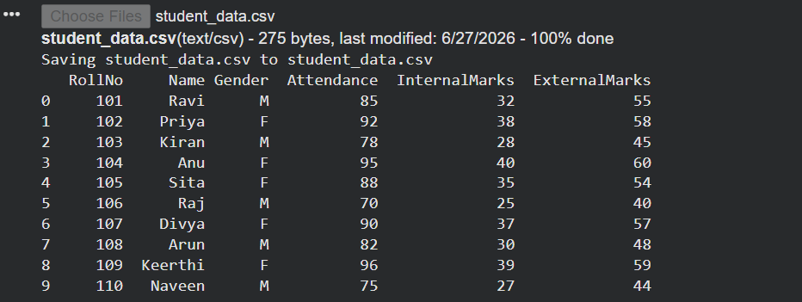

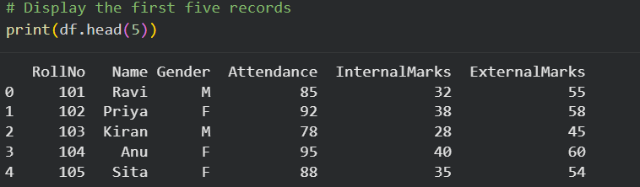

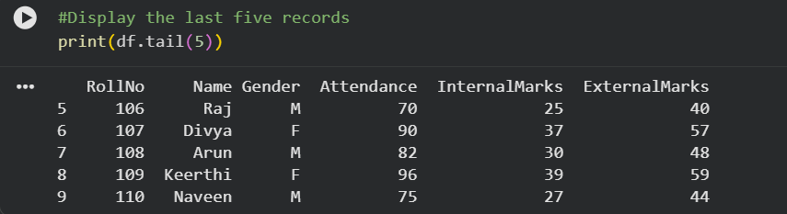

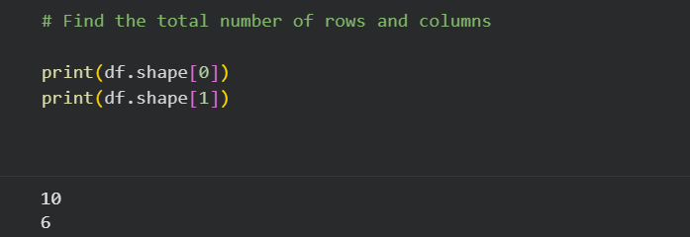

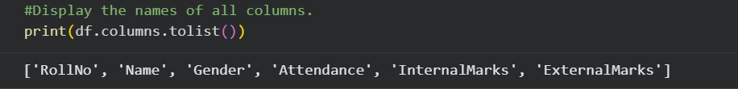

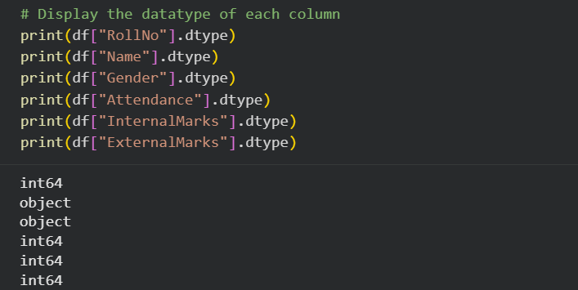

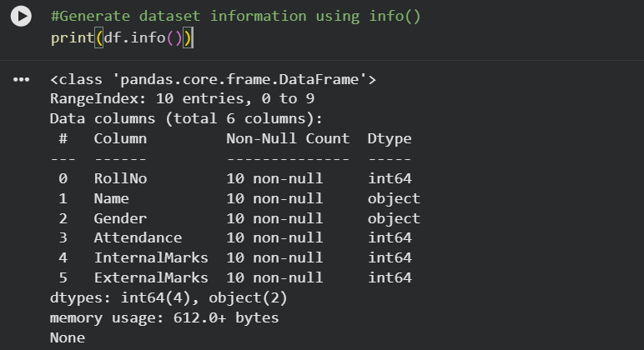

Task B: Statistical Analysis

• Calculate the mean attendance of all students.
• Calculate the average Internal Marks.
• Calculate the average External Marks.
• Find the maximum Internal Marks.
• Find the minimum Internal Marks.
• Find the maximum External Marks.
• Find the minimum External Marks.
• Calculate the standard deviation of Internal Marks.
• Generate summary statistics using describe().

Code:

# Task B

#Calculate the mean attendance of all students.

print(df["Attendance"].mean())

#Calculate the average Internal Marks

print(df["InternalMarks"].mean())

#Calculate the average External Marks

print(df["ExternalMarks"].mean())

#Find the maximum Internal Marks.

print(df["InternalMarks"].max())
#Find the minimum Internal Marks.

print(df["InternalMarks"].min())

#Find the maximum External Marks.

print(df["ExternalMarks"].max())

#Find the minimum External Marks.

print(df["ExternalMarks"].min())

# Calculate the standard deviation of Internal Marks.
print(df["InternalMarks"].std())

#Generate summary statistics using describe().

print(df.describe())

OUTPUT:





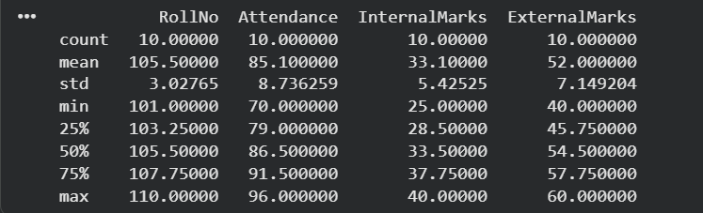

Task C: Data Manipulation
• Create a new column named TotalMarks.
• TotalMarks=InternalMarks+ExternalMarks
• Create a new column named Percentage. 1. Percentage=TotalMarks/100×100
• Display the updated DataFrame

Code:

#Task C

#Create a new column named TotalMarks.

df["TotalMarks"] = df["InternalMarks"] + df["ExternalMarks"]

print(df["TotalMarks"])

#Create a new column named Percentage.
# Percentage=TotalMarks/100×100

df["Percentage"] = df["TotalMarks"]/100*100

print(df["Percentage"])

#Display the updated DataFrame

print(df)

OUTPUT:

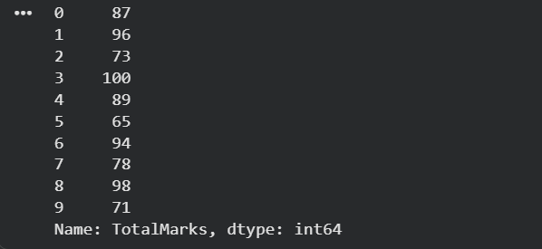
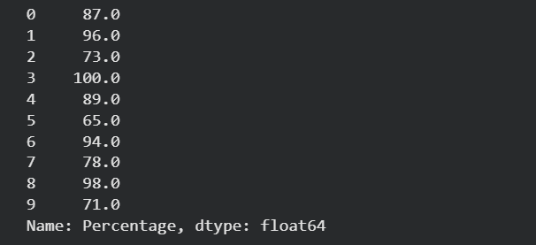

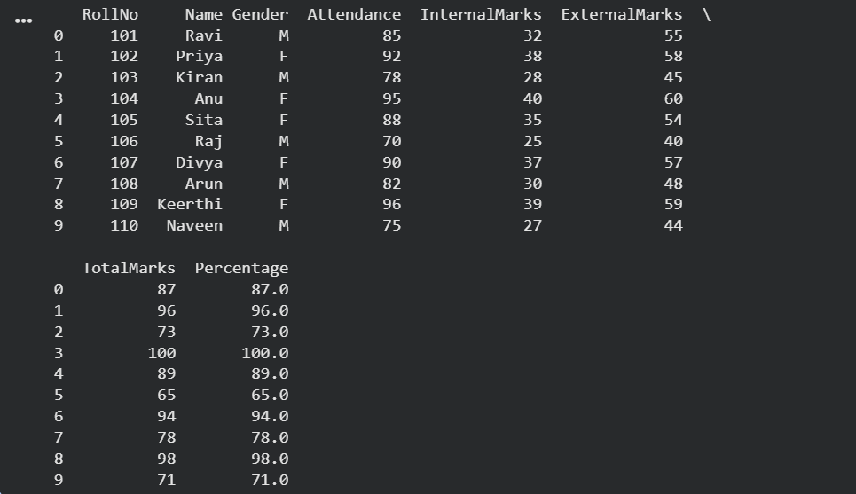

Task D: Filtering and Searching
• Display the details of students whose attendance is greater than 90%.
• Display the details of students whose TotalMarks exceed 90.
• Display the details of female students.
• Display the details of male students.
• Display students whose ExternalMarks are less than 50.

Code:

#Display the details of students whose attendance is greater than 90%.

df[df["Attendance"] > 90 ]

#Display the details of students whose TotalMarks exceed 90.
df[df["TotalMarks"] > 90]

#Display the details of female students.
df[df["Gender"] == "F"]

#Display the details of male students.
df[df["Gender"] == "M"]

# Display students whose ExternalMarks are less than 50.

df[df["ExternalMarks"] < 50]

OUTPUT:

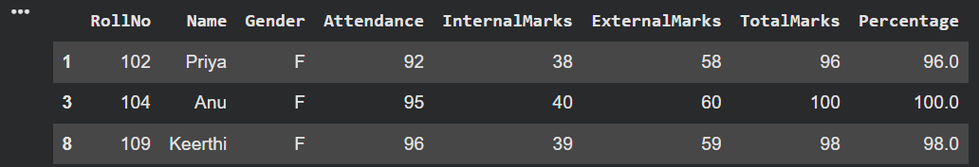
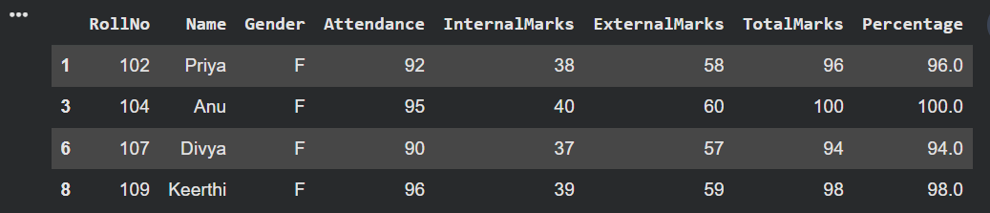
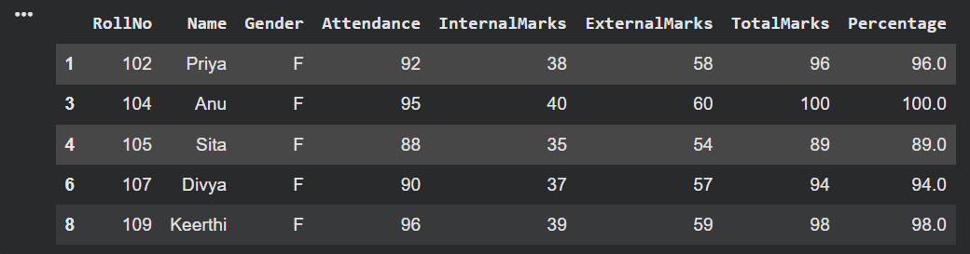
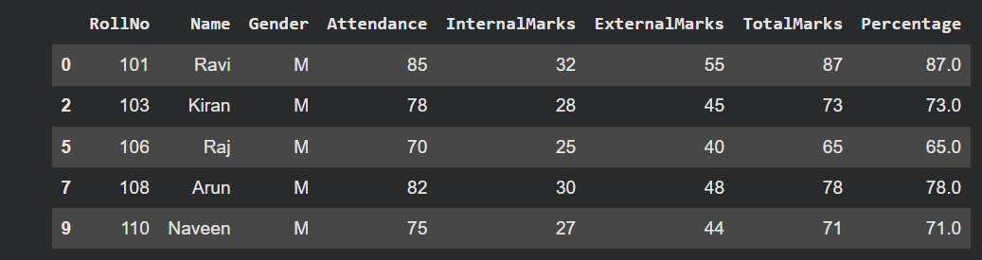
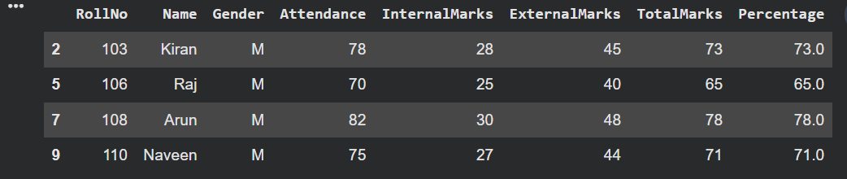

Task E: Ranking and Comparison
• Identify the student with the highest TotalMarks.
• Identify the student with the lowest TotalMarks.
• Display the top three performers based on TotalMarks.
• Display the bottom three performers based on TotalMarks.
• Determine how many students scored above the class average.

Code:

#Task E

# Highest TotalMarks
highest_student = df.nlargest(1, 'TotalMarks')['Name'].values[0]
print("Highest TotalMarks Student:", highest_student)

# Lowest TotalMarks
lowest_student = df.nsmallest(1, 'TotalMarks')['Name'].values[0]
print("Lowest TotalMarks Student:", lowest_student)

# Top 3 performers
print("\nTop 3 Performers:")
print(df.nlargest(3, 'TotalMarks')[['Name', 'TotalMarks']])

# Bottom 3 performers
print("\nBottom 3 Performers:")
print(df.nsmallest(3, 'TotalMarks')[['Name', 'TotalMarks']])

# Students above class average
avg = df['TotalMarks'].mean()
above_avg = df[df['TotalMarks'] > avg]
print(f"\nClass Average: {avg}")
print(f"Students above average: {len(above_avg)}")
print(above_avg[['Name', 'TotalMarks']])

OUTPUT:

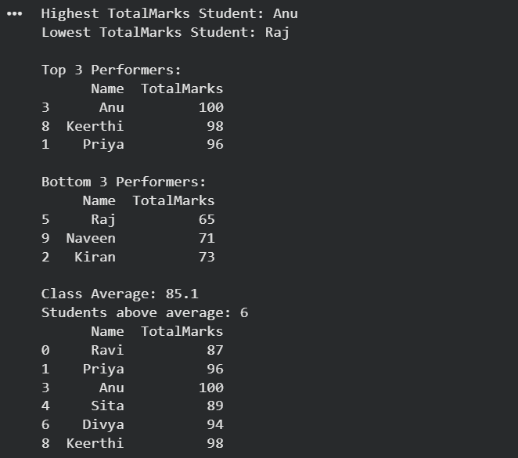

Task F: Group-wise Analysis
• Calculate the average TotalMarks of male students.
• Calculate the average TotalMarks of female students.
• Compare the average attendance of male and female students.

Code:

#Task F

# Average TotalMarks by Gender
avg_male = df[df['Gender'] == 'M']['TotalMarks'].mean()
avg_female = df[df['Gender'] == 'F']['TotalMarks'].mean()
print(f"Average TotalMarks - Male : {avg_male}")
print(f"Average TotalMarks - Female: {avg_female}")

# Average Attendance by Gender
att_male = df[df['Gender'] == 'M']['Attendance'].mean()
att_female = df[df['Gender'] == 'F']['Attendance'].mean()
print(f"\nAverage Attendance - Male : {att_male}")
print(f"Average Attendance - Female: {att_female}")

OUTPUT:
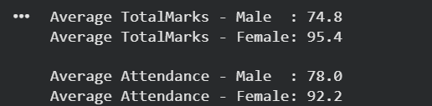

Task G: Data Visualization
• Plot a bar chart showing TotalMarks of all students.
• Plot a histogram of Attendance.
• Plot a pie chart showing the distribution of male and female students.
• Plot a scatter plot between Attendance and TotalMarks.
• Interpret the relationship between Attendance and TotalMarks.

Code:

#Task G

# 1. Bar Chart - TotalMarks of all students
plt.figure(figsize=(10, 5))
plt.bar(df['Name'], df['TotalMarks'], color='steelblue')
plt.title('TotalMarks of All Students')
plt.xlabel('Student Name')
plt.ylabel('TotalMarks')
plt.xticks(rotation=45)
plt.tight_layout()
plt.show()

# 2. Histogram - Attendance
plt.figure(figsize=(7, 4))
plt.hist(df['Attendance'], bins=5, color='orange', edgecolor='black')
plt.title('Histogram of Attendance')
plt.xlabel('Attendance (%)')
plt.ylabel('Number of Students')
plt.tight_layout()
plt.show()

# 3. Pie Chart - Gender Distribution
gender_counts = df['Gender'].value_counts()
plt.figure(figsize=(5, 5))
plt.pie(gender_counts, labels=['Female', 'Male'], autopct='%1.1f%%',
colors=['pink', 'skyblue'], startangle=90)
plt.title('Gender Distribution')
plt.show()

# 4. Scatter Plot - Attendance vs TotalMarks
plt.figure(figsize=(7, 4))
plt.scatter(df['Attendance'], df['TotalMarks'], color='green', s=100)
for i, row in df.iterrows():
plt.annotate(row['Name'], (row['Attendance'], row['TotalMarks']),
textcoords="offset points", xytext=(5, 5), fontsize=8)
plt.title('Attendance vs TotalMarks')
plt.xlabel('Attendance (%)')
plt.ylabel('TotalMarks')
plt.tight_layout()
plt.show()

OUTPUT:

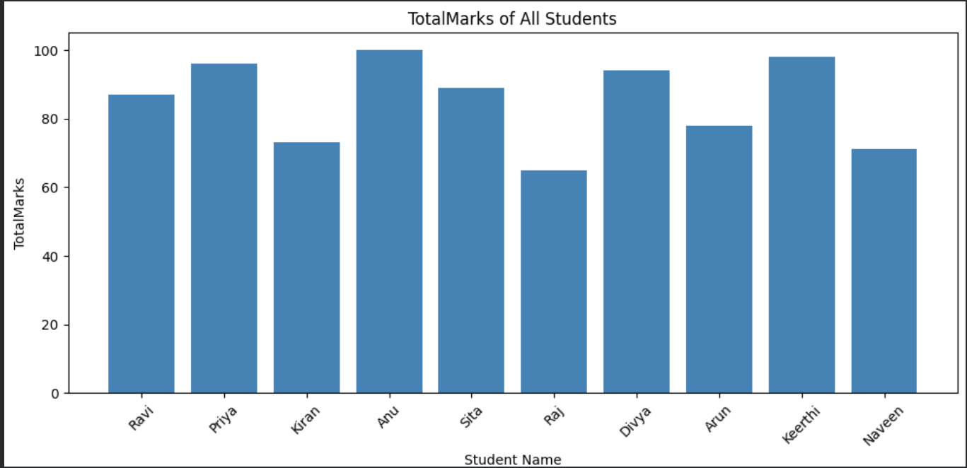
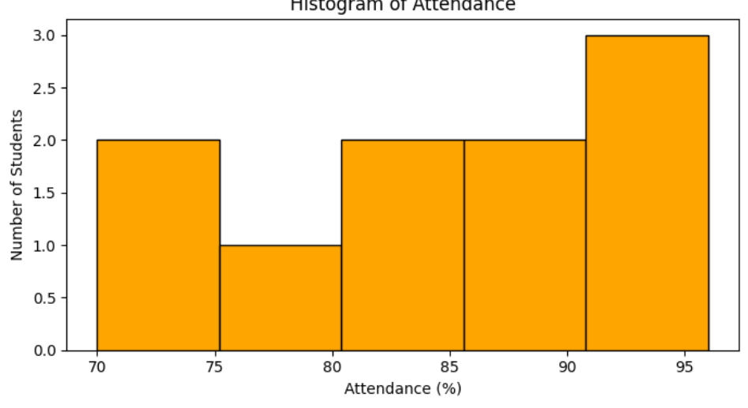
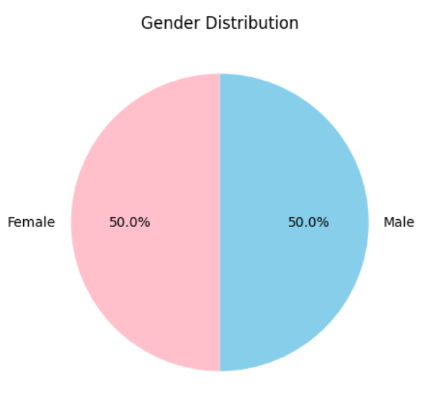
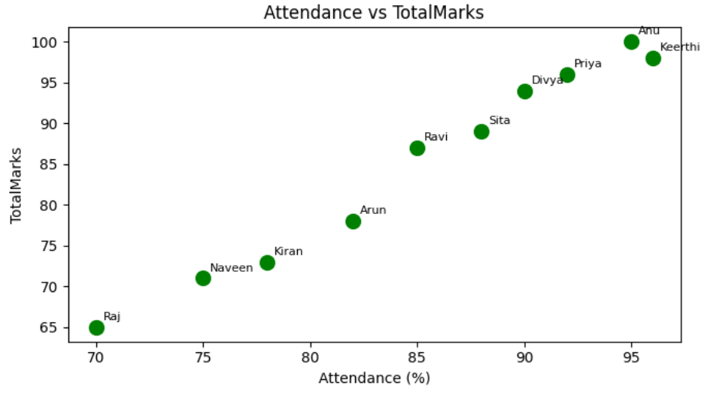

Task H: Observations

• Write any three observations based on the analysis performed.
• State whether higher attendance appears to be associated with better academic performance.

Observation:

- The student Divya scored the highest Total Marks, While Raj scored the lowest Total Marks

- The average attendance of female students is higher than that of male students, indicating that female students attended classes more regularly.

- Most students who have higher attendance also obtained higher TotalMarks, whereas students with lower attendance generally scored fewer marks.

➤ Yes, there is a connection between attendance and marks. Students with better attendance usually got higher Total Marks. Even though a few students are different, regular attendance seems to improve academic performance.

